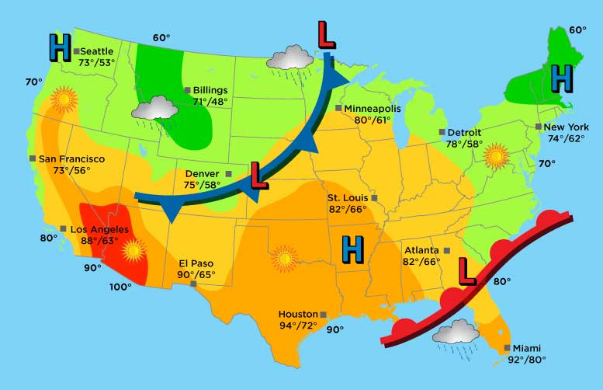
So You Want to Be a Meteorologist? Segment 1

Meteorologists spend a great deal of time collecting accurate and current weather data. But what do they do with all of that information? They create station models using various symbols to indicate the type of weather conditions at their local weather stations.

For Segment 1 of this assessment, you are going to create your own station models based on data from three different cities. This activity is going to be a lot of fun! Please read through the directions below before you start!

1. Pick any three cities for which you would like to gather weather data and create station models. These can include your hometown, a vacation spot, or a city you have always wanted to visit. If you need help finding cities around the world, click on the world map at the link below.
World Map Link

2. Open the Report Form found in the Applied Knowledge Assessment section of the lesson and record the name of each city that you have selected.

3. You will be retrieving your data from https://www.wunderground.com/intellicast.

4. After navigating to the new website, search for a city using the search bar near the top of the page.

5. From the city page, select the 'History' tab.

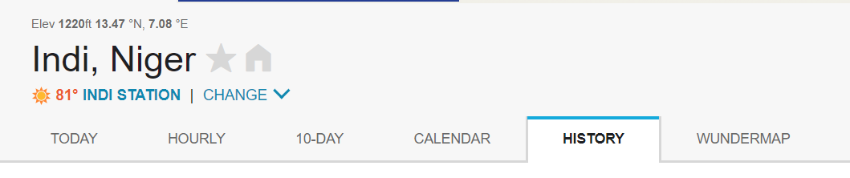

6. Scroll near the bottom of the History tab page to the section with the heading ''Daily Observations'.

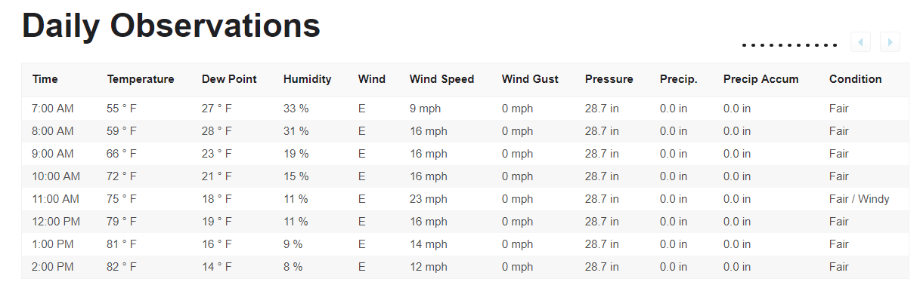

7. If it is reporting in °F, you will need to click the “°C” to get the measurements in Celsius.

8. You need to pick one specific date and one specific time. You will use this specific date and time for ALL of your cities. In other words, you need to collect your data on your three cities in one day, or the data will disappear from that 24-hour report.

9. Enter the specific date and time you will use in the appropriate areas for City #1 in your Report Form.

10. Copy the web address/URL of that page and paste it into the appropriate area in your Report Form for City #1.

11. Either copy and paste the information into your Report Form for City #1 or take a small cropped screenshot of that specific date and time and paste it into your Report Form under “Data” (see below).

12. Complete steps 3 – 11 for City #2 and City #3 so that all the data will be the same and available.

13. Once you have completed the Report Form for your three cities, you will create a station model for each one based on the information provided in your retrieved data.

14. Use Figure 2 on page 588 in your textbook to see how to make your station model.

15. Your station models can be drawn with Microsoft Word or Microsoft Paint, or they can be drawn by hand (you will need to scan these in to upload them as files for credit).

16. If you are creating your models in Microsoft Word or Paint, make sure they are embedded in your Report Form under the appropriate city headings. If you are creating these models by hand and scanning them in, make sure each model is labeled with the appropriate city name.

17. Each of your station models should include the following information:
- temperature
- dew point
- cloud cover
- wind direction/wind speed
- atmospheric pressure

Directions for Submitting Your Applied Knowledge Assessment
- If you created your station models using Microsoft Word or Microsoft Paint, your models should be included in your Report Form. In this case, you will upload only one document for grading.

- If you drew your station models by hand, you will need to label each with the correct city name, scan them into your computer, and upload each one along with your Report Form.

When you have completed the assessment, save your document(s) with your name included in the file extension. An example is provided for you below.
Example: Earth_Science_Meteorlogist1_ReportForm_JohnSmith
Earth_science_Meteorologist1_Models_JohnSmith (if you submit hand-drawn models)

After you have saved your document(s), submit it to be graded for your Applied Knowledge Assessment.

